Project Design Phase-II TechnologyStack(Architecture&Stack)

|  |  |
| --- | --- |
| Date | 18 October2022 |
| TeamID | PNT2022TMID23206 |
| ProjectName | Visualizing and Predicting Heart DiseaseswithanInteractiveDashBoard |
| MaximumMarks | 4Marks |

TechnicalArchitecture

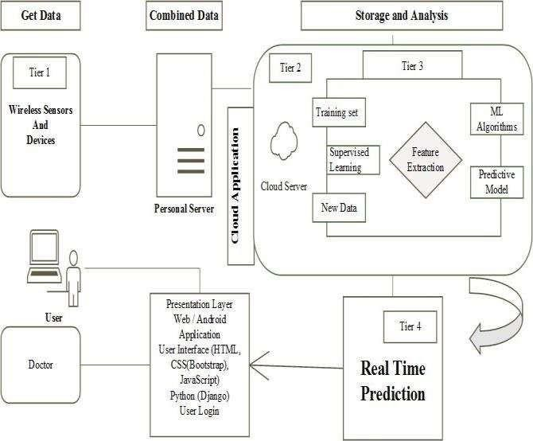

Table-1:Components&Technologies:

|  |  |  |  |
| --- | --- | --- | --- |
| **S.No** | **Component** | **Description** | **Technology** |
| 1. | UserInterface | How user interacts with application e.g.WebUI,Mobile App,etc. | HTML,CSS, Python etc. |
| 2. | ApplicationLogic-1 | Logicforaprocessintheapplication | Python |
| 3. | ApplicationLogic-2 | Logicforaprocessintheapplication | IBMCognosAnalytics |
| 4. | ApplicationLogic-3 | Logicforaprocessintheapplication | IBMWatson Assistant |
| 5. | Database | DataType,Configurationsetc. | MySQL,etc. |
| 6. | CloudDatabase | DatabaseServiceonCloud | IBMDB2,IBMPaketc. |
| 7. | FileStorage | Filestoragerequirements | UseProfessionalRecordsStorage,  IBM Block Storage or Other StorageServices. |
| 8. | ExternalAPI | Purpose of External API used in theapplication | IBMSPSS,etc. |
| 9. | Infrastructure(Server/Cloud) | ApplicationDeploymentonLocalSystem/Cloud  Local Server Configuration:CloudServerConfiguration: | PersonalServer,IBMCloudServeretc. |

Table-2:ApplicationCharacteristics:

|  |  |  |  |
| --- | --- | --- | --- |
| **S.No** | **Characteristics** | **Description** | **Technology** |
| 1. | Open-SourceFrameworks | Open-sourceframeworksused | Technology of Opensourceframework – Django or Flask inPython. |
| 2. | SecurityImplementations | Security/accesscontrolsimplemented,useoffirewallsetc. | e.g. Privacy - Encryptions, IBMSecurityManageretc. |
| 3. | ScalableArchitecture | Scalability of architecture (3 – tier, Micro-services) | Technology used - IaaS, PaaS,SaaS(IBMCloud). |
| 4. | Availability | Availabilityofapplication | Technologyused-TheAvailabilityofgetting used to this software orproduct  design isthroughbyaccessingIBMcognosAnalyticsand  IBMcloud. |
| 5. | Performance | Performanceoftheapplication | Technology used - The performanceshould be fast relaying. Thisprediction  systemshouldbemadeavailableincloudtoensurebetter  accessibilityandsettingamilestoneinprovidinggood  qualityaffordablehealthcare. |

References :https://[www.ibm.com/products/cognos-analytics](http://www.ibm.com/products/cognos-analytics)

https://cloud.ibm.com/catalog/services/watson-assistanthttps://[www.ibm.com/in-en/cloud-paks](http://www.ibm.com/in-en/cloud-paks)https://[www.ibm.com/cloud](http://www.ibm.com/cloud)